**Domain: -** Employee Salary Management

**Entities: -**

1. User
2. Login
3. Roles
4. Permission
5. Employee
6. Salary
7. Payment
8. Payroll

**Attributes and Data Types: -**

Login:

1. Login_id (Integer): Unique login identifier
2. Login_role_id (Integer): Unique role id of the user
3. Login_username (Text): Name of the user
4. User_password (Text): Password for login

User:

1. User_id (Integer): Unique user Id
2. User_name (Text): User Name
3. User_Mobile (Number): Mobile number of the user
4. User_email (Text): Email of the user
5. User_address (Text): Address of the user

Roles:

1. Role_id (Integer): Unique role id
2. Role_name (Text): Role
3. Role_desc (Text): Description of the role

Permission:

1. Per_id (Integer): unique permission id
2. Per_role_id (Integer): permission role id
3. Per_module (Text): Module name as permission id
4. Per_name (Text): Permission Name

Payment:

1. Pay_cus_id (Integer): payment customer id
2. Pay_id (integer): Unique payment id
3. Pay_date (Date): date of the payment
4. Pay_desc (Text): Payment description
5. Pay_amt (Number): Amount paid

Salary:

1. Sal_desc (Text): Salary description
2. Sal_type (Text): Salary type
3. Sal_emp_id (Integer): employee salary id
4. Sal_amt (Integer): salary amount
5. Sal_id (Integer):

Payroll:

1. Pyrl_id (Integer): unique payroll id
2. Pyrl_type (Text): payroll type
3. Pyrl_desc (Text): payroll description

Employee:

1. Emp_add (Text): Employee address
2. Emp_id (Integer): unique employee id
3. Emp_name (Text): employee name
4. Emp_mobile (Integer): employee mobile number
5. Emp_pass (integer): employee password
6. Emp_email (Text): employee email

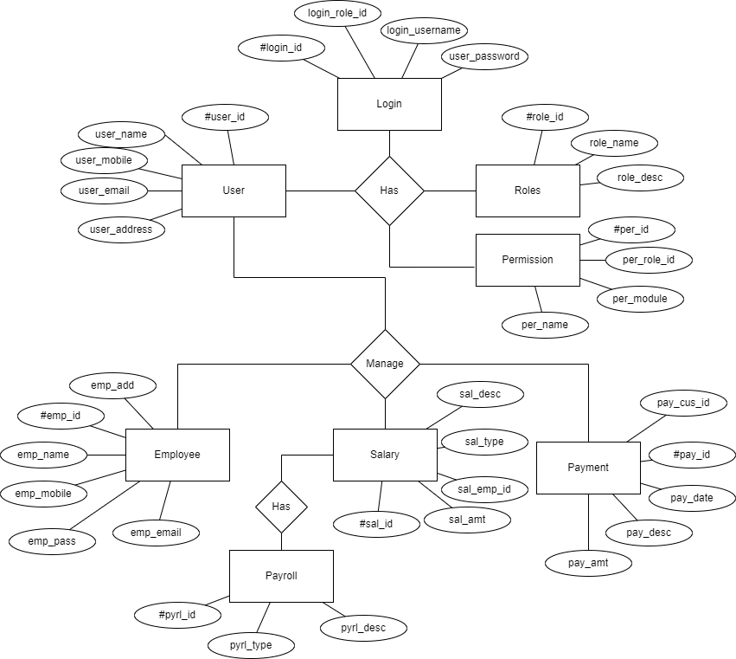

ER DIAGRAM EMPLOYEE SALARY MANAGEMENT

In the above ER Diagram, the attributes represented with # are primary key values, which are unique for every employee